LAB MST

(A)
An online store maintains customers and their orders. Display customers whose total purchase amount is greater than the total purchase amount of every other customer from the same city.

Display Customer Name, City, and Total Purchase Amount. If two customers from the same city tie for the highest total, display both.

CODE:
SELECT
c.customer_name,
c.city,
SUM(o.amount) AS total_purchase
FROM Customer c
JOIN Orders o
ON c.customer_id = o.customer_id
GROUP BY
c.customer_id,
c.customer_name,
c.city
HAVING SUM(o.amount) >= ALL (
SELECT SUM(o_sub.amount)
FROM Customer c_sub
JOIN Orders o_sub
ON c_sub.customer_id = o_sub.customer_id
WHERE c_sub.city = c.city
GROUP BY c_sub.customer_id
)
ORDER BY c.city, c.customer_name;

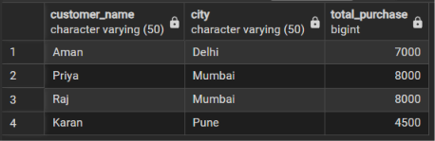

(B) An inventory system stores products in product_inventory. Create a trigger that automatically records a log whenever a product is inserted or deleted. Store Product ID, Product Name, action (PRODUCT ADDED/PRODUCT REMOVED), and current timestamp in product_audit.

CODE:
CREATE OR REPLACE FUNCTION log_product_changes()
RETURNS TRIGGER AS $$
BEGIN
IF (TG_OP = 'INSERT') THEN
INSERT INTO product_audit (product_id, product_name, action, action_timestamp)
VALUES (NEW.product_id, NEW.product_name, 'PRODUCT ADDED', CURRENT_TIMESTAMP);
RETURN NEW;

ELSIF (TG_OP = 'DELETE') THEN
INSERT INTO product_audit (product_id, product_name, action, action_timestamp)
VALUES (OLD.product_id, OLD.product_name, 'PRODUCT REMOVED', CURRENT_TIMESTAMP);
RETURN OLD;
END IF;

RETURN NULL;
END;
$$ LANGUAGE plpgsql;SS

